Name: Mriganka Patra

Email: [mriganka.patra@cognizant.com](mailto:mriganka.patra@cognizant.com)

Emp ID: 2415820

Day 18

Sprint 1 Submission

Task 1.7: As a system I want to auto-create an Opportunity when a new Account is added so that sales tracking begins immediately.

1. Go to Setup
3. 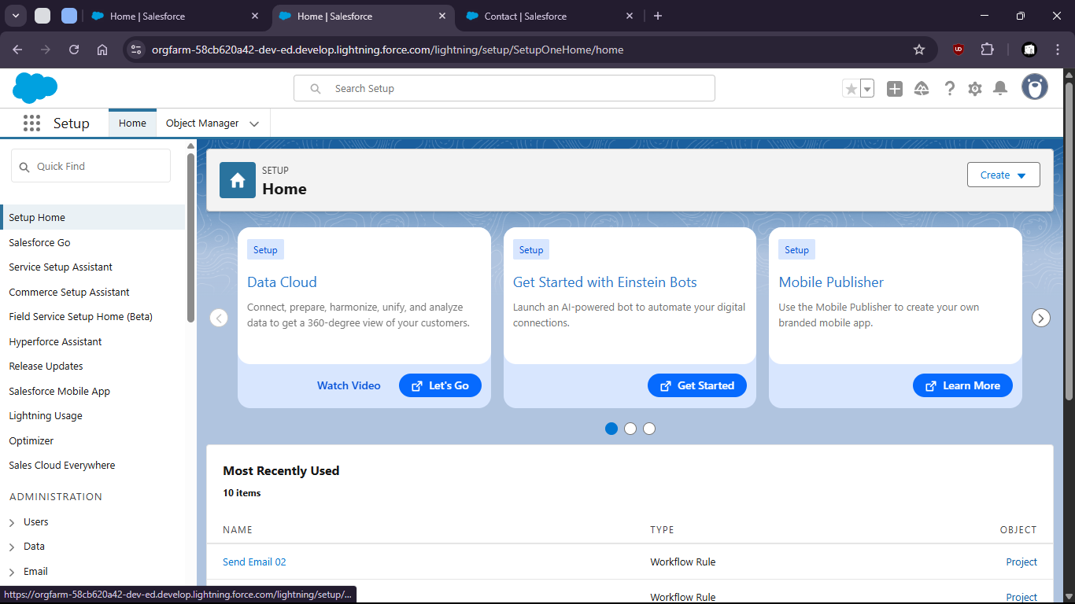
5. Search for “Flows”
7. 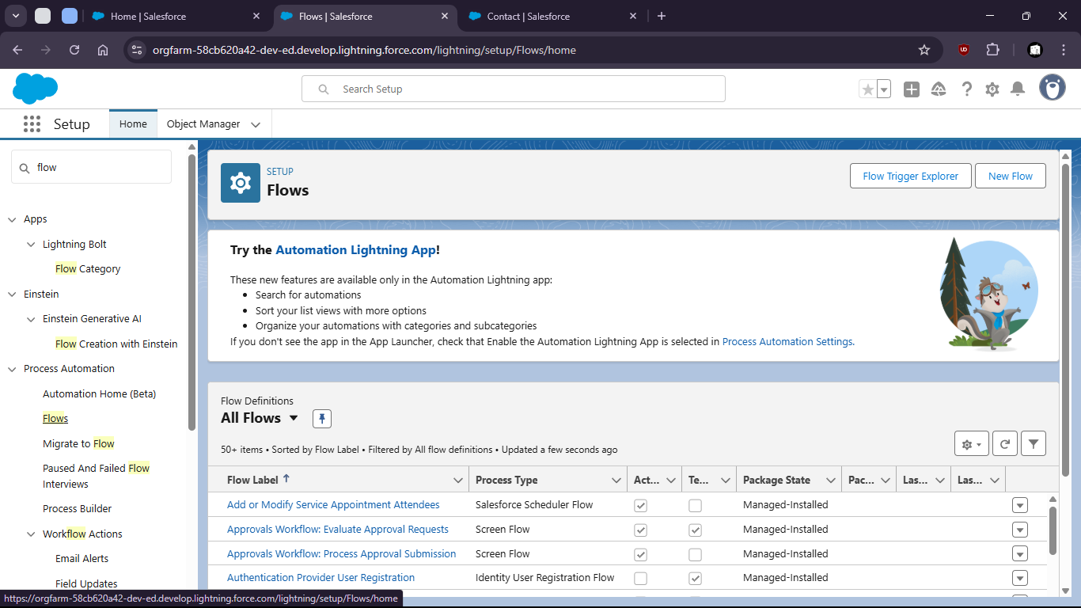
9. Click new
11. 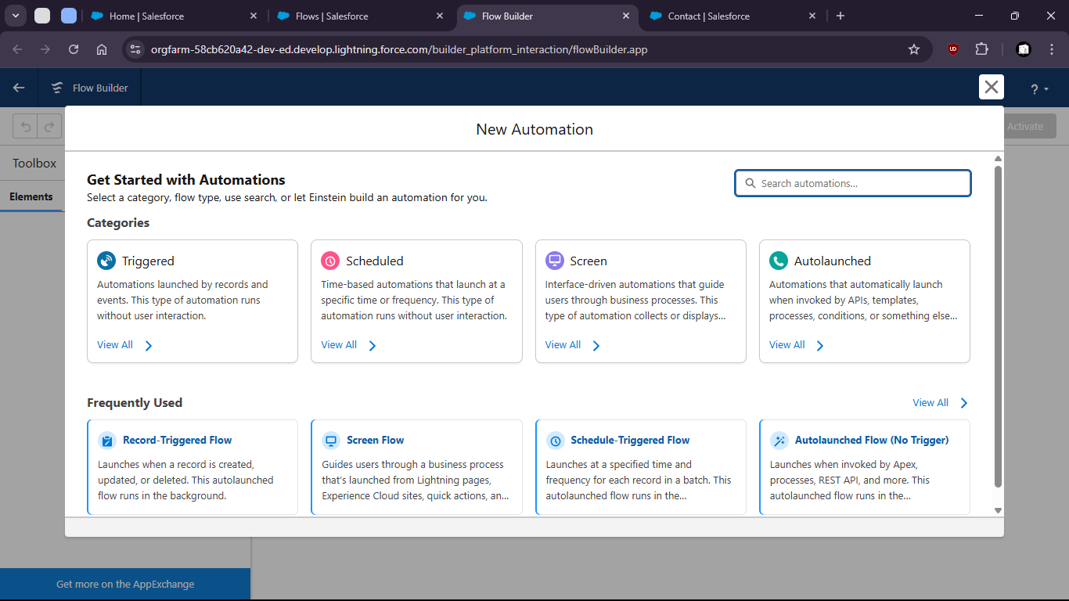
13. Select Record Triggered Flow
15. 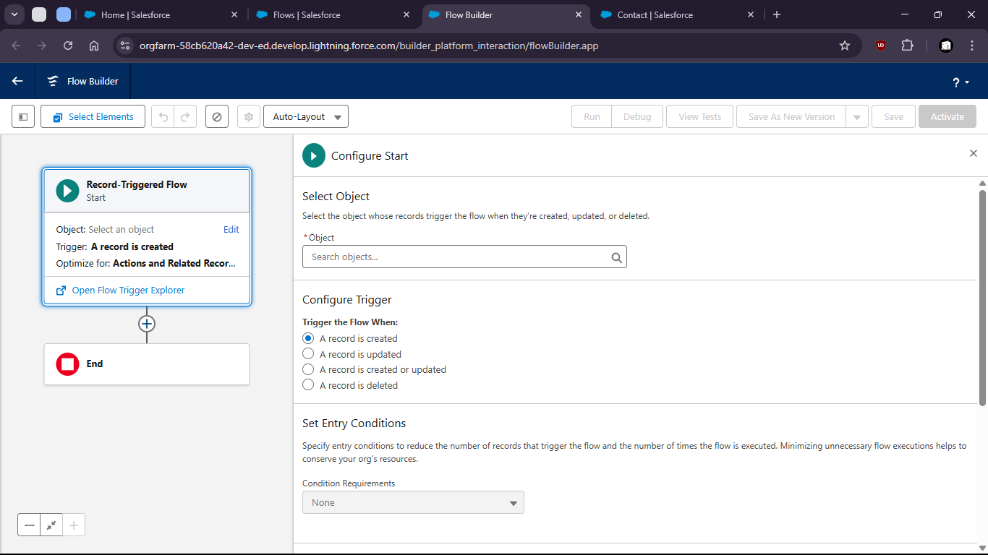
17. Select Account as Object

20. 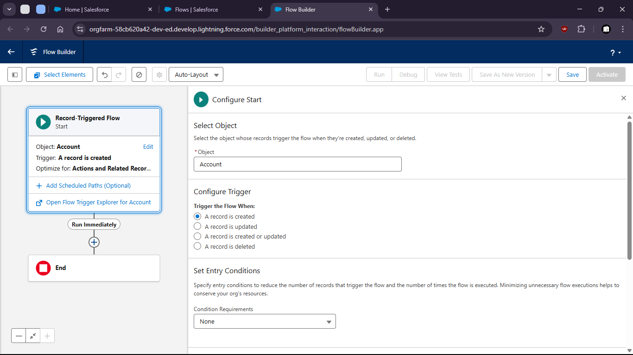

23. Add Create Records Element

26. 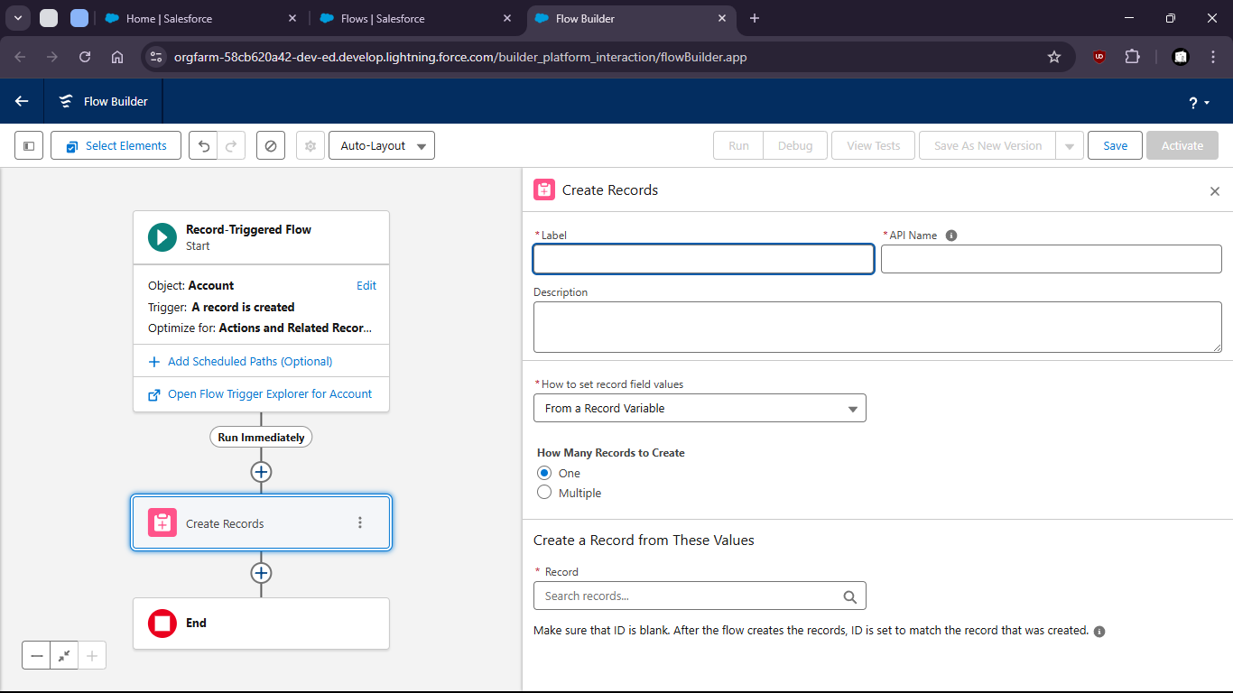

29. 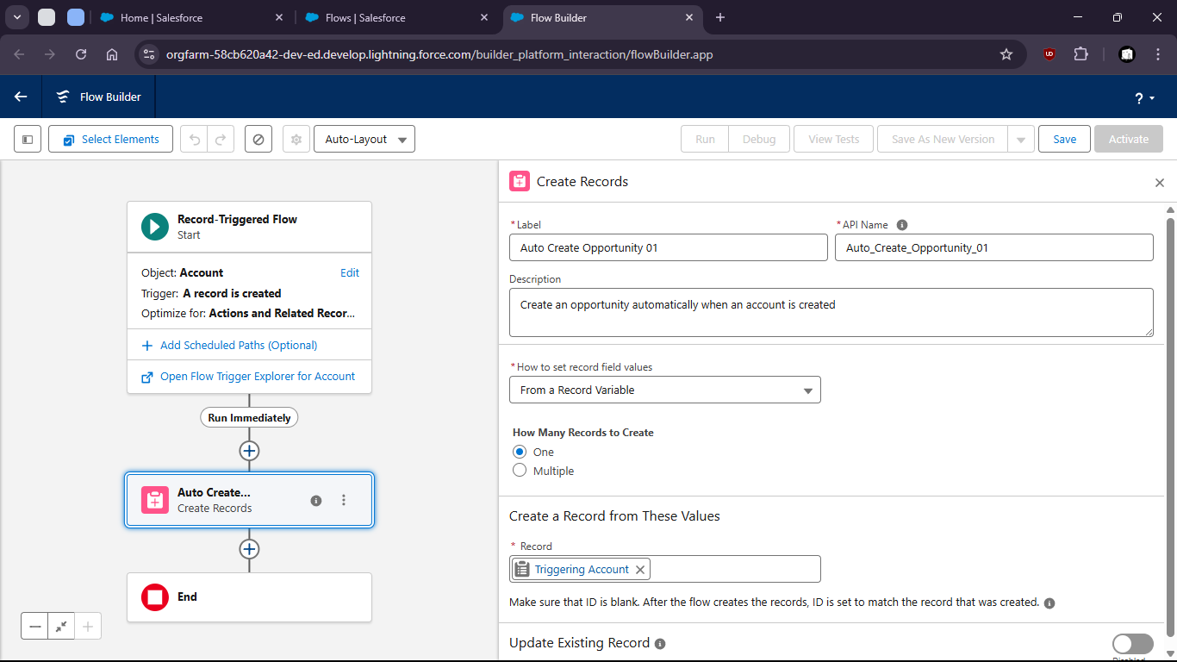


33. 